1. Who is the customer who spent the most on rental movies? Return his/her customer id, first name and the amount spent.

**Answer:**

Customer id is 13

First name: Karen

Amount spent - $ 11.99



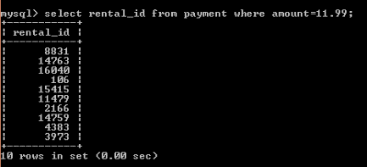



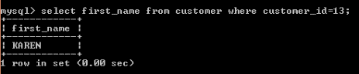

1. Give an interesting query of your own that is not already in the assignment. The query should involve at least two joins, HAVING clause and aggregation operation. Give the English explanation and the answer.

**Answer:**

SELECT customer_name, MIN (balance) from account GROUP By customer_name HAVING min(balance) > 10000

UNION

SELECT customer_name from loan;